Lab Programs 6-10
NAME:D.CHAND BASHA
REG NO:192424218
6. prices = [50, 30, 20]
quantities = [2, 1, 3]
discount_rate = 10 # %
tax_rate = 5 # %
subtotal = sum([p*q for p, q in zip(prices, quantities)])
discount_amount = subtotal * (discount_rate / 100)
after_discount = subtotal - discount_amount
tax_amount = after_discount * (tax_rate / 100)
total_cost = after_discount + tax_amount
print("Total cost:", total_cost)
OUTPUT:

- import pandas as pd
order_data = pd.DataFrame({
"customer_id": [1,1,2,2,3],
"order_date": pd.to_datetime(["2024-01-01","2024-01-15","2024-01-05","2024-01-20","2024-01-18"]),
"product_name": ["Apple","Banana","Apple","Mango","Banana"],
"order_quantity": [2,3,1,5,4]
})
orders_per_customer = order_data.groupby("customer_id")["order_date"].count()
avg_qty_per_product = order_data.groupby("product_name")["order_quantity"].mean()
earliest_date = order_data["order_date"].min()
latest_date = order_data["order_date"].max()
print(orders_per_customer)
print(avg_qty_per_product)
print(earliest_date, latest_date)

OUTPUT:
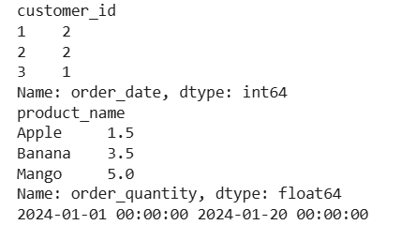

- import pandas as pd
sales = pd.DataFrame({
"product": ["A","B","A","C","B","D","A"],
"quantity": [5,3,2,7,1,4,6]
})
top5 = sales.groupby("product")["quantity"].sum().sort_values(ascending=False).head(5)
print(top5)
OUTPUT:
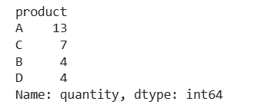

- import pandas as pd
property_data = pd.DataFrame({
"property_id": [1,2,3,4],
"location": ["A","B","A","C"],
"bedrooms": [3,5,6,4],
"area": [1200,2500,3000,1800],
"price": [300000,550000,600000,400000]
})
avg_price_location = property_data.groupby("location")["price"].mean()
count_bedrooms = len(property_data[property_data["bedrooms"] > 4])
largest_area_property = property_data.loc[property_data["area"].idxmax()]
print(avg_price_location)
print(count_bedrooms)
print(largest_area_property)
OUTPUT:
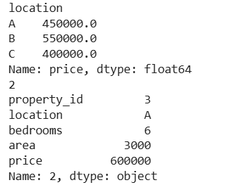

- import matplotlib.pyplot as plt
months = ["Jan","Feb","Mar","Apr","May"]
sales = [200, 300, 250, 400, 450]
plt.plot(months, sales, marker='o')
plt.title("Monthly Sales - Line Plot")
plt.xlabel("Month")
plt.ylabel("Sales")
plt.show()

OUTPUT:
